**CHANDIGARH UNIVERSITY**

**UNIVERSITY INSTITUTE OF ENGINEERING**

**DEPARTMENT OF COMPUTER SCIENCE AND ENGINEERING**



|  |  |
| --- | --- |
| **Submitted by:**  Yash Gupta  20BCS5009 | **Submitted To:**  Er. Bhupinder Singh  (12856) |
| **Subject Name:** | Multimedia Technologies Lab |
| **Subject Code:** | 20CSP-339 |
| **Branch:** | CSE |
| **Semester:** | 5th |

LAB INDEX

|  |  |  |  |  |  |  |  |
| --- | --- | --- | --- | --- | --- | --- | --- |
| **Sr.No** | **Program** | **Date** | **Evaluation** | | | | **Sign** |
| **LW(12)** | **VV(8)** | **FW(10)** | **Total (30)** |
|  |  |  |  |  |  |  |  |
|  |  |  |  |  |  |  |  |
|  |  |  |  |  |  |  |  |
|  |  |  |  |  |  |  |  |
|  |  |  |  |  |  |  |  |
|  |  |  |  |  |  |  |  |
|  |  |  |  |  |  |  |  |

**Experiment 7**

**Student Name: Yash Gupta UID: 20BCS5009**

**Branch: BE-CSE Section/Group: 20BCS-MM-806 A**

**Semester: 5 Date of Performance: 29-09-2022**

**Subject Name: MMT LAB Subject Code:**

**Aim :-** Import two pictures, one of the seas and another of the clouds. Morph, merge and overlap the images using adobe Photoshop or Photopea.

**Hardware Requirements: -** Minimum 384MB RAM, 100 GB hard Disk, processor with 2.1 MHz

**Software Requirements: -** Adobe Photoshop, Photopea

**Tools to be used:** Raster Mask, Gradient Tool (G).

**2.1 Procedure to merge two photos together: -**

Step 1: Create the two new projects and set the dimensions according to the requirement.

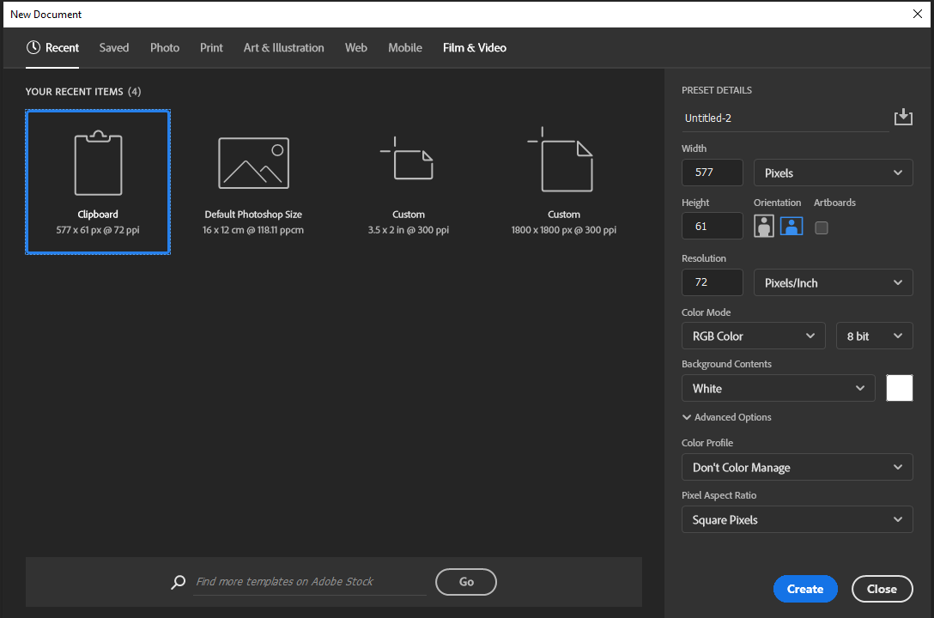

Step 2: Drag one background image to another image.

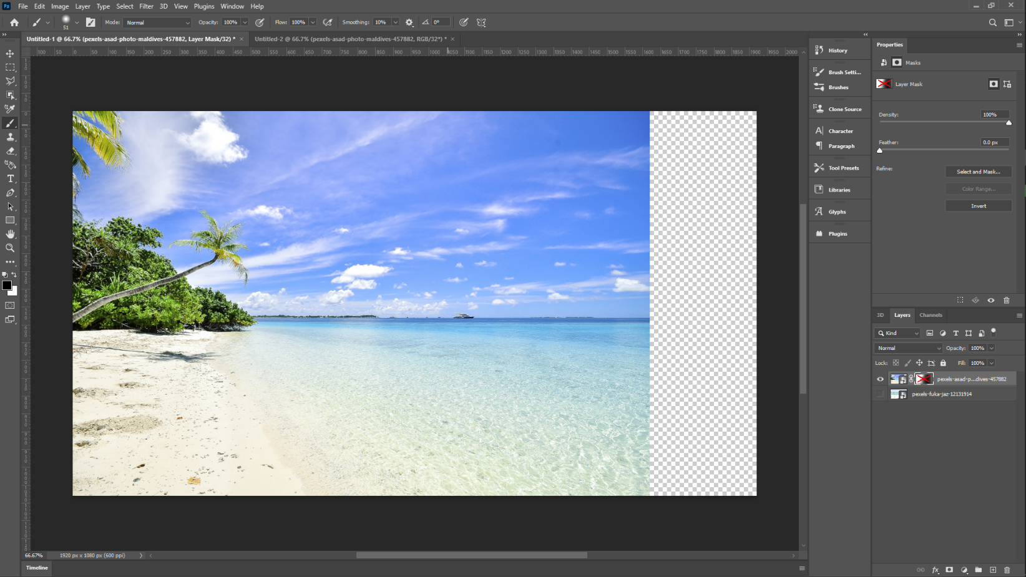

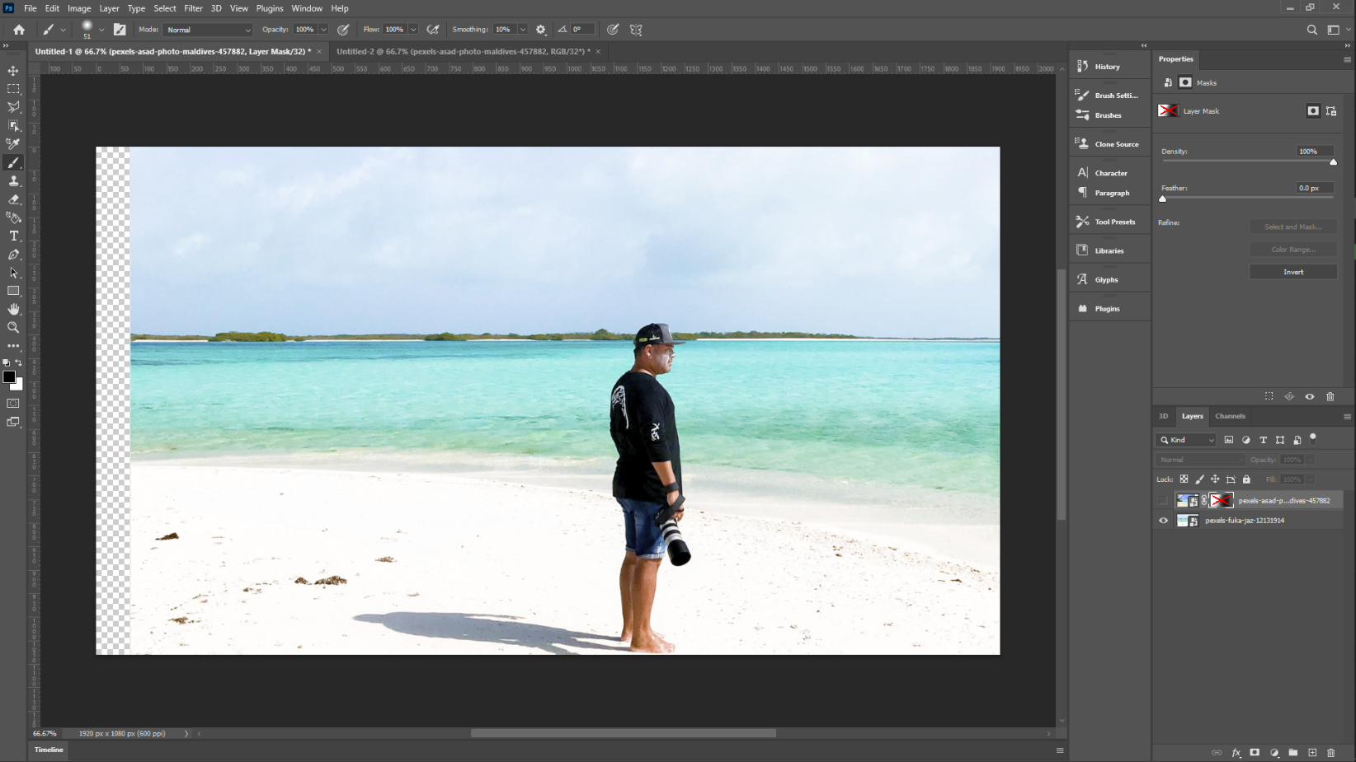

Step 3: Drag the second background image over to the first image with the person in the layers section.

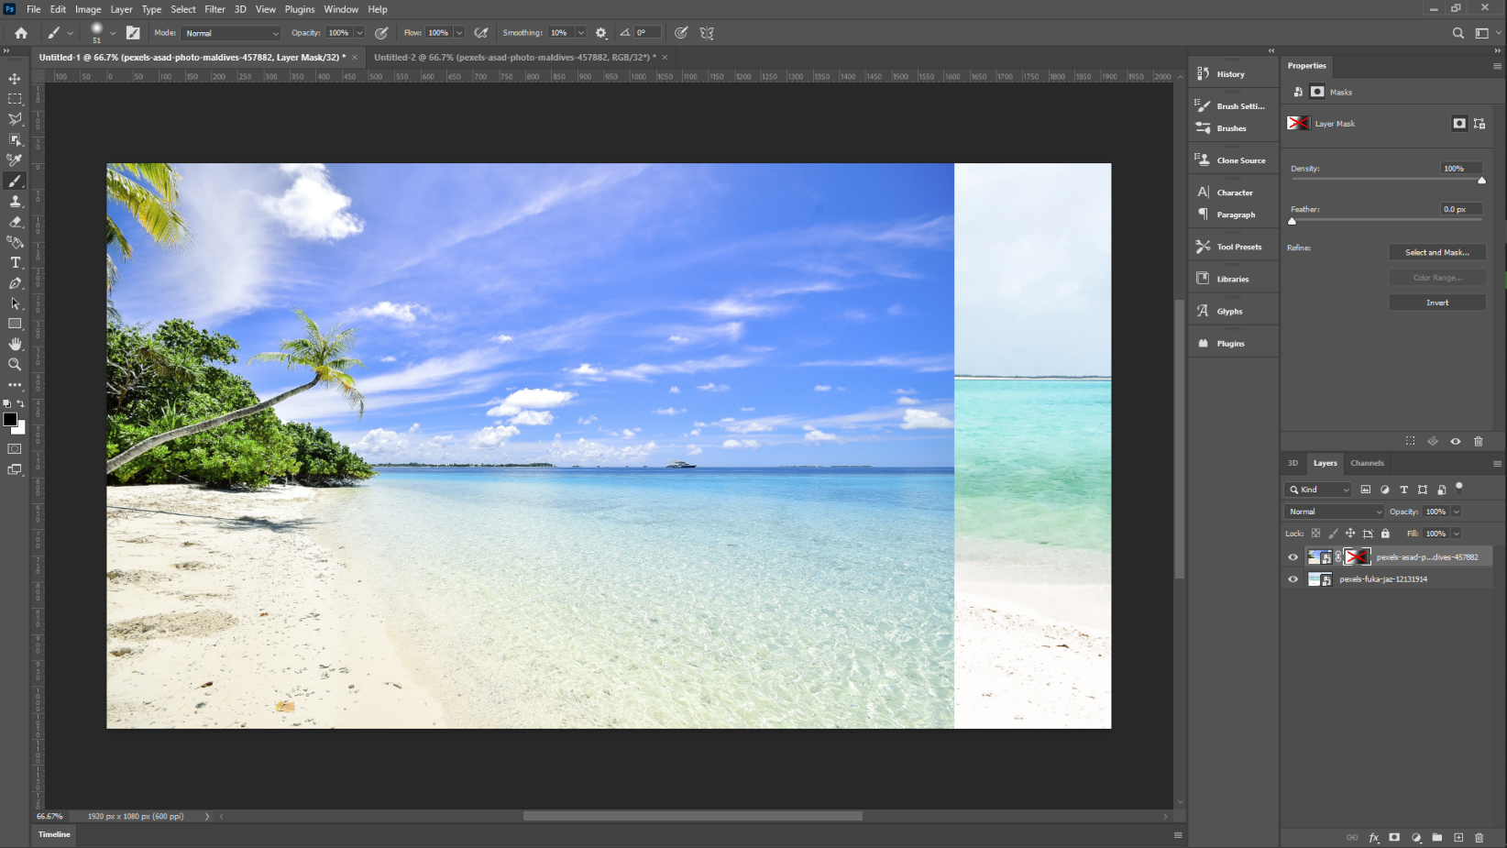

Step 4: Go to Layers > Raster Mask > Add Reveal(ALL).

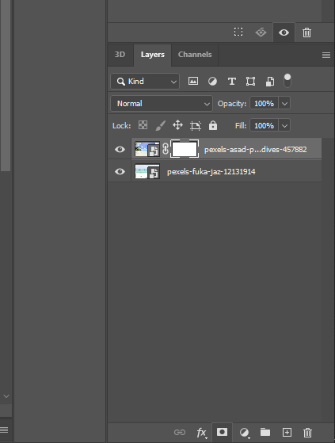

Step 5: Now with brush tool paint with white color for making the layer visible and black color to make the part invisible.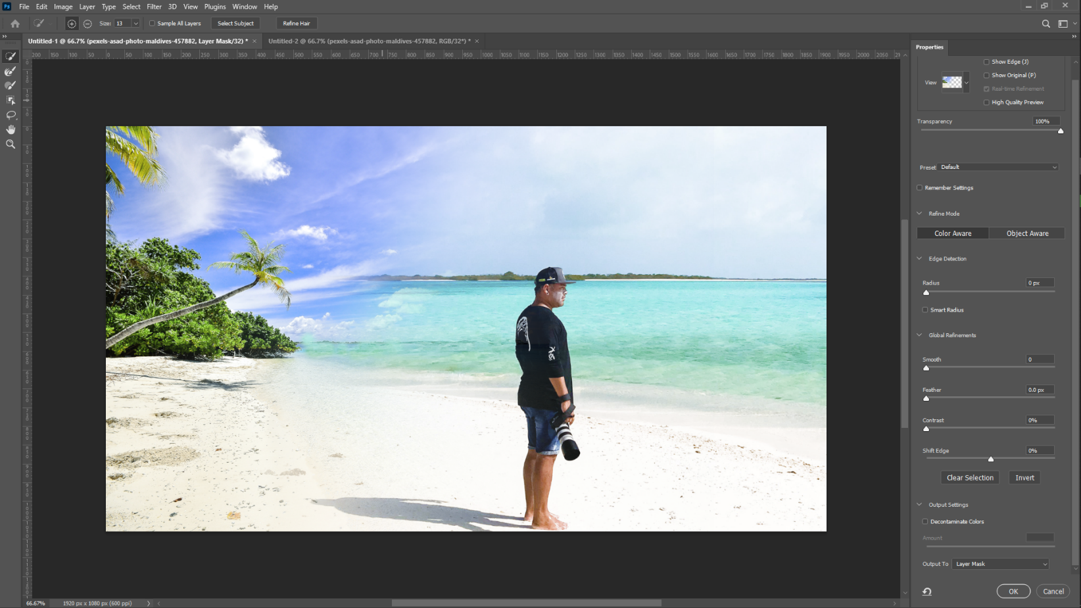

**2.2 Procedure to merge two photos together: -**

Step 5: Import first and second image.

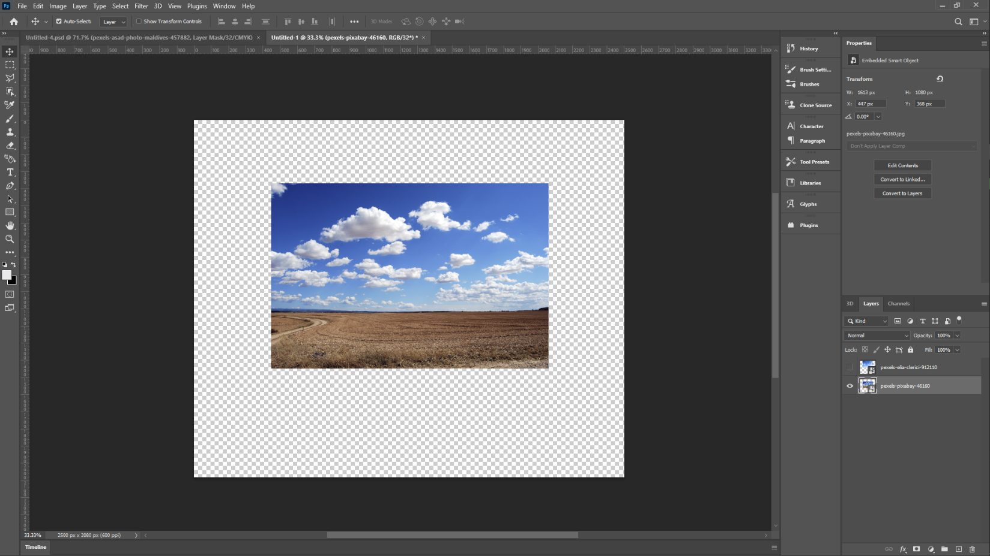

Step 2: Combine both images in one layer.

Step 3: Create a masking layer and with bush tool make the layer visible and see through with use of Black and

White paint.

# Output :-

**Evaluation Grid (To be created as per the SOP and Assessment guidelines by the faculty):**

|  |  |  |  |
| --- | --- | --- | --- |
| Sr. No. | Parameters | Marks Obtained | Maximum Marks |
| 1. |  |  |  |
| 2. |  |  |  |
| 3. |  |  |  |